TYNE CENTRAL COUNCIL – 200 CLUB

January 2026 RESULTS

1st (£50) 134
SVP Conference St Joseph’s, Sunderland
Mary Broadly All Saints, Lanchester

2nd (£25) 147
P Lake Our Lady of Lourdes, Wallsend
Tom Collins St Joseph’s Birtley
Thank you for your continued support.
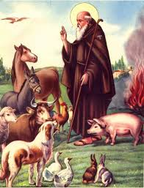

St Anthony the Abbot - Feast Day 17th January
He was born in Egypt in 251and at the age of twenty he renounced everything to live as a hermit until 106 years of age. He is the Patron Saint of the pets, livestock, farmers and related works such as butchers, bakers, grocers, basket makers, shearers and also gravediggers.

147 | Lake P | Our Lady of Lourdes | Wallsend
147 | Collins Tom | St Joseph's | Birtley

