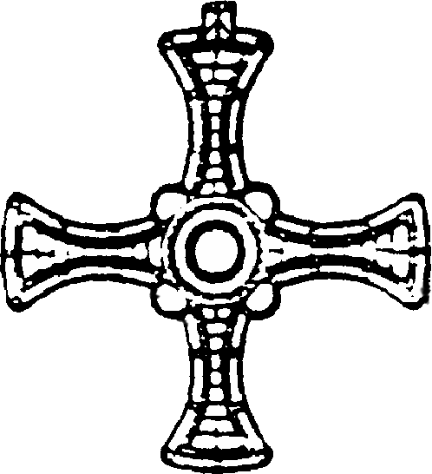St John XXIII

Washington and Penshaw

Fr Martin Morris

St John XXIII Parish

Village Lane

Washington Village

Washington

NE38 7HS

1st April 2025

Dear Confirmation Candidate

The clergy and all parishioners of St John XXIII invite you to join our Confirmation preparation programme, ready to be confirmed in November this year.

To express your interest please complete the on-line form on our Church Desk application. Simply scan the QR code below or follow this link;

(<https://forms.churchdesk.com/f/seZRIcSEs_>) and complete the contact details. Please complete the form by 9th May 2025. There will be an information session on Sunday 18th May. Details will be provided to those who register. At the meeting you will be able to find out more about our programme and to meet the catechists who will be accompanying you on your journey towards Confirmation.

The programme itself will begin in mid-June and will continue after the Summer Holidays.

We acknowledge the special role your parents/guardians will play in supporting you in your preparation for Confirmation. Therefore, they too are invited to join you at this information meeting. We will be issuing forms that your parents/guardians need to sign. We will be asking for details of your baptism so please bring along your Baptism certificate or details of where and when you were baptised.

I do hope you will be able to accept this invitation and look forward to seeing you then.

With very best wishes. 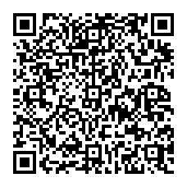

Fr Martin Morris

If you have any questions, please contact Deacon Tony Joy (07799 893419)